Saraswathi
  - Database Design V1
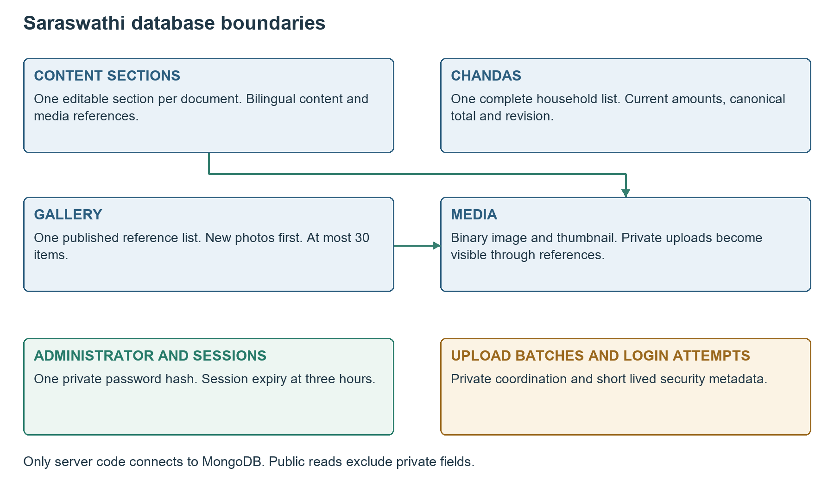
Figure 1 Logical collections and the private server boundary
Engineering specification for the Saraswathi Puja single page website. This document turns the agreed product behaviour into implementable contracts for the Next.js monolith, its sole administrator and public readers.
Document detail | Value
Version and date | 1.0 | 15 October 2026
Platform | React and Next.js on Vercel; separate MongoDB Atlas database
Celebration | 16 to 20 October 2026; main programme on 16 October
Audience | Frontend and backend engineers, reviewers and testers

1 Database Contract and Product Rules
Use the saraswathi_puja production database and saraswathi_puja_test for non-production verification. Both are separate from Make My Marriage. One scoped application database user serves each environment. Database access remains server-only.
Rule | Required stored behaviour
Whole section saving | One aggregate per independently editable section; one revision-checked commit
Chandas controls | The complete household array is the Save boundary; no row-level Save API
Current contribution only | Store the final household total; replace 100000 with 150000 paise when the organiser enters INR 1500
No payment history | No instalments, previous amounts, cash versus UPI ledger or automatic reconciliation
Pending | Store null; never infer nonpayment from an unrecorded amount
Gallery | One reference list; newly published images precede existing images; maximum 30
Identity | One administrator; private password hash; absolute three-hour sessions
Languages | One business record with English and Telugu text; financial values are shared
Publication | Drafts stay in browser memory; new reads see the successful committed snapshot

1.1 Field dictionary conventions
All fields listed in this document are required unless marked optional or nullable. Objects reject unknown fields at the application boundary. BSON Date stores instants in UTC; JSON examples show ISO 8601 strings ending in Z. Local event dates use YYYY-MM-DD and times use HH:mm in Asia/Kolkata. Date-only values are never converted through UTC midnight.
BilingualText means {en: string, te: string}. Both values must be nonblank for required public content. Optional bilingual text is null or contains both values. IDs exposed in JSON are lowercase UUID strings; database singleton keys are the fixed strings described below. schemaVersion starts at 1.

1.2 Engineering limits
Baseline safeguards are 1000 household rows, 120 Unicode code points per name, 200 per short title, 2000 per description, 2,000,000 bytes per JSON request and per non-media BSON aggregate. These are engineering safeguards rather than a limit of 130 households. Reject excess input clearly without truncating saved data.

2 Collections and Shared Aggregate Fields
Collection and key | Cardinality and purpose
content_sections / section key | Seven documents: welcome, announcement, programme, puja_prasadam, committee, venue, donation
chandas / current | Exactly one document with embedded household entries
gallery / current | Exactly one document containing published item references
media / UUID | One document per main image and its thumbnail
media_batches / UUID | Private upload coordination scoped to one editable section
admin_accounts / primary | Exactly one administrator account
admin_sessions / token digest | Zero or more independent, short-lived sessions for that account
login_attempts / opaque bucket key | Short-lived failed sign-in counters

2.1 Shared editable aggregate fields
Field | BSON type | Meaning
_id | string | Fixed section key or current
schemaVersion | int | 1; future migrations are explicit
revision | int | Starts at 0; increments once per actual saved content change
createdAt | date | Server time at initial provisioning
updatedAt | date | Last actual content change; nullable for an untouched initial Chandas list
updatedBy | string or null | primary after an admin change; null for seed content
recentCommits | array | Bounded technical receipts; never prior household values

2.2 Technical receipts without amount history
Each receipt contains operationId UUID, requestHash SHA-256 hex, committedRevision int, committedAt Date and changed boolean. Keep at most the newest 64 receipts and prune receipts older than 24 hours during writes. Receipts are embedded and committed atomically with their target aggregate. A no-op Save may append a receipt without changing revision or updatedAt.
The hash covers the normalised intended payload, target scope and expected revision. Reusing an operation ID for different content is rejected. Receipts contain no previous or current contribution amounts, names or snapshots. They support bounded retry resolution, not an audit history. A private operation read returns the current snapshot rather than reconstructing an old one.

3 Public Content Section Schemas
Each content_sections document includes the shared fields and a data object with the exact shape for its key. Immutable celebration identity fields are seeded and validated server-side. A section Save replaces its complete data object, preserving other sections.
Section | Fields inside data and rules
welcome | celebrationName: BilingualText; message: BilingualText; deviMediaId: UUID or null; startDate: 2026-10-16; endDate: 2026-10-20; mainDate: 2026-10-16; timezone: Asia/Kolkata
announcement | state: pending or confirmed; message: BilingualText; eventDate: date string or null; eventTime: time string or null; venueNote: BilingualText or null
venue | name: BilingualText or null; address: BilingualText or null; mapsUrl: safe Google Maps HTTPS URL or null
donation | qrMediaId: UUID or null; linkedMobile: ten-digit Indian mobile string or null; cashInstructions: BilingualText

3.1 Missing and confirmed information
Pending Annadanam requires eventDate and eventTime to be null and the approved bilingual pending message. Confirmed requires eventDate; an unknown time may remain null and render a translated pending label. Annadanam can fall outside the five celebration dates. Do not store animation position or pause state in MongoDB.
Venue and donation details can start incomplete, but never invent an address, phone number or QR. Pairwise content is validated: a published QR requires a verified linked number; supplied venue name and address each require both language versions. Release checks confirm the real Maps target and payment destination.

3.2 Media references
welcome.deviMediaId and donation.qrMediaId reference media._id. A non-null reference must identify a validated media record allowed for that section. A staged new reference must belong to the admin upload batch supplied with the Save. Existing unchanged references must already belong to that section. Never accept a guessed media ID from another private batch.

3.3 Public field projection
Public reads include section data, approved media URLs and useful update times. Exclude recentCommits, updatedBy, upload batch ownership, database binary payloads and private identity fields. All prose is plain text. The server validates HTTPS Maps hosts using an explicit allowlist, including maps.app.goo.gl, maps.google.com and google.com/maps paths.

4 Programme Prasadam and Committee Schemas

4.1 programme data
Path | Type and constraint
days | Array of exactly five day objects, in 16 to 20 October order
days[].date | Fixed date string; dates unique and cannot be removed
days[].events | Array of event objects; at most 100 per day
event.id | Stable UUID
event.title | Required BilingualText, at most 200 code points per language
event.description | Nullable BilingualText, at most 2000 code points per language
event.startTime / endTime | Nullable local HH:mm strings; end requires start and must not precede it
event.locationNote | Nullable BilingualText

Order timed programme events by startTime, then preserve submitted order for ties; untimed events follow timed entries in submitted order. No sample event is seeded as real content. The main programme marker derives from the fixed mainDate rather than an editable duplicate flag.
The programme document also has a server-only top-level linkGuardVersion integer, initially 0. Programme and puja_prasadam Save transactions both increment it to serialize linked-event checks. It is not a public content revision.

4.2 puja_prasadam data
Path | Type and constraint
days | Exactly five objects containing date, pujas and prasadam
pujas[] | {id, title: BilingualText, time: HH:mm or null, programmeEventId: UUID or null}
prasadam[] | {id, items: BilingualText, distributionTime: HH:mm or null, locationNote: BilingualText or null}

At most 100 puja entries and 100 prasadam entries per day, subject to the aggregate byte limit. When programmeEventId is supplied, it must refer to an event on the same day. That event is the authoritative title and time; linked puja title and time are null in storage. Resolve them during reads. Reject a programme Save that removes a referenced event; unlink the puja first. Do not write conflicting duplicate times.

4.3 committee data
members is an ordered array of at most 200 objects: id UUID, name BilingualText, role BilingualText, photoMediaId UUID or null and publicContact string or null, at most 40 characters. Contacts and photos are optional and organiser-approved. Array order is the display order. Committee records have no account or permission linkage.

5 Chandas Schema and Current Amounts
Field | Type and rule
_id | Fixed string current; shared aggregate fields apply
currency | Fixed INR
households | Ordered array of at most 1000 household objects
household.id | Permanent UUID; unique within the aggregate
household.name | Required BilingualText; both spellings at most 120 code points
household.amountPaise | BSON long or null; positive integer when recorded
totalPaise | BSON long; server sum of all non-null household amounts
updatedAt | Null before first saved household change; otherwise server Date

Amounts use integer paise and must remain within JavaScript safe-integer range when exposed as JSON numbers. Reject any row or combined total above 9,007,199,254,740,991 paise. There is no separately stored status: null maps to Pending and a valid positive value maps to Paid. There are no payment dates, payment methods, previous amounts or instalment arrays.

5.1 Example current document
{
"_id": "current", "schemaVersion": 1, "revision": 3,
"currency": "INR",
"households": [
{"id": "11111111-1111-4111-8111-111111111111",
"name": {"en": "Example Household", "te": "ఉదాహరణ కుటుంబం"},
"amountPaise": 150000},
{"id": "22222222-2222-4222-8222-222222222222",
"name": {"en": "Another Household", "te": "మరో కుటుంబం"},
"amountPaise": null}
],
"totalPaise": 150000,
"createdAt": "2026-10-15T04:30:00Z",
"updatedAt": "2026-10-16T14:30:00Z", "updatedBy": "primary",
"recentCommits": []
}

Example names and values are illustrative, not real household data. JSON dates represent BSON Date fields. The initial organiser-reviewed list is seeded with null amounts. Transcription from supplied photographs is a preparation activity; no OCR or Telegram integration is added.

5.2 Search and household identity
Preserve the organiser supplied array order. Different households may share a name; IDs distinguish them. Detect likely duplicate entries as warnings, not a unique-name constraint. Search both spellings in the loaded browser list after Unicode and whitespace normalisation. Search never changes the stored total.

6 Atomic Saving Concurrency and Retry

6.1 Whole list commit algorithm
- Authenticate, validate CSRF and parse the entire draft; reject duplicate household IDs, invalid bilingual fields and unsafe amounts.
- Read the current aggregate. Resolve an existing matching operation receipt before evaluating the expected revision. A different hash for that ID is a conflict.
- Require the supplied expectedRevision to equal the stored revision. Recompute totalPaise from the complete submitted list.
- For an actual change, atomically replace households and total, set server updatedAt and updatedBy, increment revision and append the bounded receipt.
- Use an update filter containing _id, revision and absence of this operationId. If it matches no document, reread to distinguish a successful duplicate retry from a stale revision.
- Return the canonical current snapshot after acknowledgement. Do not report success when the database result is uncertain.
MongoDB provides atomic single-document writes, and matching the expected revision prevents concurrent overwrites. A bulk update across separate household documents would not provide this whole-list boundary. Use acknowledged majority writes with a bounded timeout and primary reads for these mutations. [D1]

6.2 No-op and replacement semantics
If the submitted content is unchanged, record a technical no-op receipt while preserving revision, total and updatedAt. For a contribution change from INR 1000 to INR 1500, write amountPaise = 150000. Do not add 150000 to the old value. Clearing to null restores Pending. Removing a paid household or clearing its amount requires explicit confirmation flags in the request, checked against the current snapshot.

6.3 Retry receipts and old tabs
An exact replay returns replayed = true, its committedRevision and the current snapshot. If newer changes exist, the current snapshot can have a greater revision; the server never restores the earlier state. An absent or expired receipt means unknown, not proof of failure. Retain the draft, fetch current data and require review if the outcome cannot be established.
Do not automatically merge conflicting amounts. Reject a stale revision even for a no-op if a matching receipt is absent. Append receipts for no-op requests with a revision match and operation absence condition so concurrent no-op writes do not duplicate receipts.

6.4 Other editable sections
Use the same revision, whole-snapshot replacement and bounded receipt algorithm for content_sections and gallery. There is no Save All across unrelated sections. Save and Cancel for Chandas cover all households; Save and Cancel for Gallery cover all photos. Cancel never writes published content.

7 Gallery Schema and Newest First Order
Field | Type and rule
_id | Fixed string current; shared aggregate fields apply
items | Array of zero to 30 published item objects
item.id | Stable UUID identifying the gallery entry
item.mediaId | Unique UUID referencing media; no duplicate image ID in this gallery
item.caption | Nullable BilingualText; at most 200 code points per language
item.alt | Required BilingualText; at most 200 code points per language
item.publishedAt | Server Date set once when the item is first published

7.1 Canonical ordering
The stored items array is the public display order. On Save, place newly added items before retained items. Within the new group use file selection order, with the last selected image first. Retained items preserve their existing order. Upload completion time, EXIF capture dates and client clocks do not determine public order. Editing a caption does not move a photo.
The server generates publishedAt and rejects attempts to alter it on retained items. New entries use new stable client-generated item IDs. An uploaded file may already be old in capture date; it still counts as newly published on the website. No manual drag-and-drop reordering feature is required in V1.

7.2 Draft and published references
A new media record is private until a successful section commit references it. Public access is established by current gallery or content section references, not by a client-supplied published flag. The gallery commit verifies each new media ID belongs to the administrator, allowed batch and gallery scope. Previously published items may be retained or removed, but a removed private file cannot be resurrected by guessing its ID.

7.3 Replacement and removal
Replacing a gallery photo removes its old item and adds a new one, which appears first. A successful Save removes unwanted references atomically, then permits safe later file cleanup. One failed upload or invalid item prevents publication of the new list. The existing gallery remains intact.
{
"_id": "current", "schemaVersion": 1, "revision": 2,
"items": [{
"id": "33333333-3333-4333-8333-333333333333",
"mediaId": "44444444-4444-4444-8444-444444444444",
"caption": null,
"alt": {"en": "Puja celebration", "te": "పూజ వేడుక"},
"publishedAt": "2026-10-16T12:00:00Z"
}],
"createdAt": "2026-10-15T04:30:00Z",
"updatedAt": "2026-10-16T12:00:00Z",
"updatedBy": "primary", "recentCommits": []
}

8 Media and Upload Batch Schemas
media field | Type and constraint
_id / schemaVersion | UUID string / 1
ownerId / scope | primary / gallery or permitted image-bearing section key
batchId / clientFileId | Upload batch UUID / stable per-selection UUID
originalName | Private filename string, at most 255 code points; never a filesystem path
main | Object with bytes BSON binData, mimeType, byteLength, width, height, sha256
thumbnail | Same object shape as main; mandatory small preview
createdAt | Server Date of successful validated file storage

Stored output types are image/jpeg, image/png or image/webp. HEIC and HEIF are accepted as original selections but converted in the browser. Main image bytes must be at most 3,000,000 and thumbnail bytes at most 200,000. Each decoded variant must have positive dimensions and at most 60 million pixels. Validate real signatures and decode success with bounded memory before storage.
main.sha256 and thumbnail.sha256 are computed server-side over their bytes; byteLength and dimensions are derived, not trusted. Images at or below 3 MB in a compatible format keep their main bytes unchanged. Only browser-generated previews are additional variants. No Base64 storage or raw original copy is retained.
media_batches field | Type and constraint
_id / schemaVersion | Batch UUID / 1
ownerId / scope | primary / target section key or gallery
baseRevision | Nonnegative revision used to open this draft
state | open or abandoned; publication is resolved from the target aggregate receipt
createdAt / expiresAt | Server dates; new batch lifetime 24 hours
clientBatchId | UUID for idempotent creation
maxFiles | Server allowance: gallery at most 30; welcome or donation 1; committee 200

An expired batch rejects new uploads and new publication, but previously published referenced files remain valid. Reauthentication can resume an unexpired batch owned by primary; it does not extend the batch expiry. Enforce at most two open batches per scope and a conservative server byte budget across private staged uploads. Baseline private staging ceiling is 100 MB, subject to measured shared Atlas headroom.

9 Media Publication and Safe Cleanup
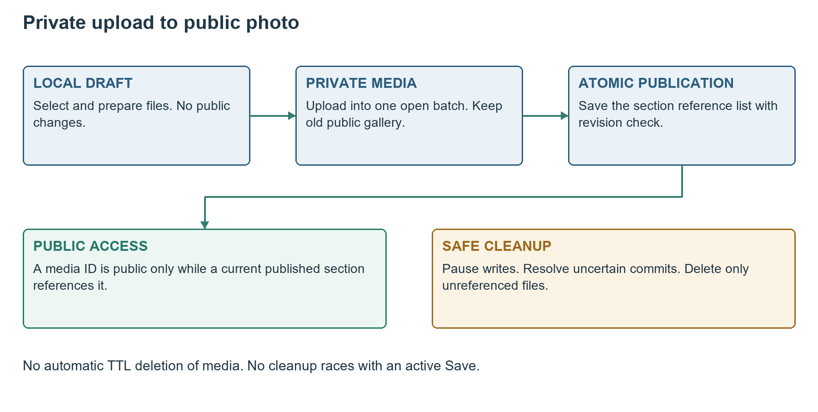
Figure 2 Reference publication is the visibility boundary

9.1 Uploads and commits are separate
Store each validated image atomically with its thumbnail before publishing it. Enforce uniqueness of batchId plus clientFileId. A repeat with matching main and thumbnail hashes returns the existing media ID. A different file under the same clientFileId is rejected. No staged URL is publicly readable.
The final section Save validates the current batch and all proposed references, then commits only the section aggregate. It includes its receipt and authoritative media references in the same atomic update. Updating batch metadata afterward is optional; publication never depends on that second write succeeding.

9.2 Cleanup procedure
No TTL index is placed on media or media_batches. Physical deletion is a maintenance action with administrator writes paused at the server and in-flight operations drained. Resolve uncertain commits first, then read all current gallery and content media references. Delete only unreferenced records from abandoned or expired batches, or old replaced assets; delete their batch metadata only after checking references. Repeat reference checks before deletion.
Cancelling Gallery discards the local draft. If files have already been staged during an interrupted Save, mark that batch abandoned after resolving its commit result. Abandonment never deletes published media. Referenced image bytes survive session expiry, batch expiry and deployments.

10 Administrator and Session Schemas
admin_accounts field | Type and rule
_id / schemaVersion | primary / 1; prevents a second normal account
emailNormalized | Trimmed lower-case email, at most 254 characters
password | Object: algorithm scrypt, saltBase64, hashBase64, N, r, p, keyLength
enabled | Boolean; true for the sole active account
createdAt / updatedAt | Server Date; no password recovery UI

Baseline scrypt parameters are N=131072, r=8, p=1, 16 random salt bytes and a 64-byte derived key, with explicit maxmem of at least 256 MiB. Benchmark the asynchronous Node.js implementation on the deployed runtime before release. Compare derived bytes in constant time. Provision privately; do not seed a demo password, log it or include it in the website bundle. [D4 D5]
admin_sessions field | Type and rule
_id | SHA-256 hex digest of a 32-random-byte opaque session token
schemaVersion / adminId | 1 / primary
csrfDigest | SHA-256 hex digest of an independent random CSRF token
issuedAt / expiresAt | Server Dates; expiresAt exactly issuedAt plus 10800 seconds

The separate CSRF cookie supplies the token for a request header and its digest must match the private session record. Only the session cookie is HttpOnly. A missing CSRF cookie is treated as needing a fresh sign-in. Neither cookie is stored in localStorage.
Set session cookie __Host-saraswathi_session with Secure, HttpOnly, SameSite=Strict, Path=/ and no Domain. Set __Host-saraswathi_csrf with Secure, SameSite=Strict, Path=/ and no Domain, readable by the site script. Both expire at the same three-hour deadline. Successful sign-in rotates both values; sign-out deletes the current record and both cookies.

10.1 Expiry and independent tabs
Every protected operation checks the record, enabled account and expiresAt against server time. Activity never extends expiry. TTL removes old session records eventually and does not enforce permission. Tabs share cookies; a fresh sign-in updates the browser session used by other tabs. Separately signed-in browsers can have separate three-hour sessions. [D2]

11 Login Protection Validation and Indexes

11.1 login_attempts schema
Fields are _id opaque SHA-256 key for the trusted source IP and 15-minute UTC bucket, schemaVersion 1, failureCount int, windowStart Date and expiresAt Date at bucket end plus 15 minutes. Store no readable IP or entered password. Count failed credential checks atomically. Five failures block further attempts until that bucket ends; return Retry-After. Counter is shared across server instances. Use only deployment-trusted client-IP metadata.
Collection | Index | Purpose
All collections | _id unique default | Singletons and exact record lookups
admin_accounts | emailNormalized unique | Prevent duplicate normalised identities
admin_sessions | expiresAt ascending TTL 0 | Remove expired sessions eventually
admin_sessions | adminId ascending | Revoke account sessions during controlled maintenance
login_attempts | expiresAt ascending TTL 0 | Expire security counters
media | batchId + clientFileId unique | Retry-safe per-file upload
media | batchId ascending | List and inspect batch uploads
media_batches | ownerId + scope + clientBatchId unique | Idempotent batch creation
media_batches | ownerId + scope + state | Find active batches and enforce staging safeguards

11.2 Schema and application validation
Create collection validators with validationLevel strict and validationAction error. Use MongoDB $jsonSchema for required keys, BSON types, enums, bounds and nested array item shapes. Chandas amountPaise accepts long or null and totalPaise is long. media bytes use binData. Do not confuse MongoDB BSON schemas with JSON wire examples. [D3]
Application validation additionally enforces cross-field rules, distinct embedded IDs, exact five dates, canonical totals, revision checks, allowed media references and linked programme events. Database validators alone cannot establish all cross-document relationships. No full-text or name uniqueness index is required for browser-side household search.

11.3 Cross-section consistency
A programme Save cannot invalidate a linked puja reference. Use a short transaction that reads both sections, increments programme.linkGuardVersion on every programme or puja_prasadam Save, checks links and applies the target revision-checked change. Touching the shared guard forces competing transactions to conflict and retry rather than allowing write skew. Recheck all rules on retry. No-op content keeps its content revision and timestamp. Never hold a transaction while a person edits or uploads files. [D1]

12 Provisioning Capacity and Recovery

12.1 Controlled initialisation
- Verify the exact Atlas cluster and database names. Create the scoped production and test users and collections, validators and indexes.
- Create the sole admin privately, seed seven content sections, empty gallery and Chandas revision 0. Never overwrite an existing populated aggregate during startup.
- Import only reviewed bilingual household names, all Pending. Preserve stable IDs on an intentional re-import. Show a review before any replacement.
- Seed empty five-day programme and prasadam slots. Keep unconfirmed Annadanam, absent photos and missing venue details honest.
- Set schemaVersion 1 and record a private initial backup. Verify test credentials cannot modify production or Make My Marriage.

12.2 Resource and network safeguards
Reuse the MongoClient in each warm Node.js runtime, starting with maxPoolSize 5 and a finite server-selection timeout. Never open and close a new pool per request. Tune against shared Atlas usage. Separate databases still share cluster capacity. Thirty 3 MB gallery main files total up to 90 MB, with thumbnails, other assets, staging and indexes using additional space.
Atlas Free currently provides 512 MB for data and indexes and does not include managed backups. Confirm actual available headroom and transfer limits before publishing. Use lazy thumbnails and bounded image caching; these limits are deployment facts to recheck, not guaranteed free capacity for this project. [D6 D7]

12.3 Backup and restore
Before launch and after each completed daily Chandas update or significant photo batch, pause administrator writes and take a protected database-scoped mongodump backup including media. Store it outside the public repository. Test mongorestore into saraswathi_puja_test; verify household counts, totals, bilingual text and all referenced files. During production recovery pause writes, verify the target, restore, revoke restored sessions and check content before reopening editing. [D7]

12.4 Schema changes and retention
Use explicit versioned migrations with a pre-change backup and test restore. Normal code redeployments never reset or reseed populated data. Retain the current website content and images after the festival; there is no event-date deletion. Historical backup copies naturally contain the snapshot captured at backup time, but the live application exposes no contribution history.

13 Verification and Technical References
Check | Required result
Initial households | Reviewed bilingual names, unique IDs and null amounts
Amount replacement | 100000 to 150000 increases total by 50000; no payment record added
Atomic failure | One invalid row commits none of the list
No-op Save | No amount, revision or updatedAt change
Conflict | An old revision cannot overwrite a newer snapshot
Replay | Matching operation does not save twice; mismatched payload is rejected
Language search | Both spellings find one household without affecting total
Newest photos | New group precedes retained items; last selected new file first
Media isolation | No public access before reference publication
Expiry | Protected access fails at 10800 seconds even if TTL has not run
Cleanup | Referenced media survives expired batches and maintenance
Cross-section links | Concurrent programme and puja updates cannot create dangling references
Restore | Isolated restore reproduces totals and readable referenced images

Implementation follows this schema contract and the companion API Design V1. The PRD and architecture establish scope; these specifications clarify exact persistence and transfer behaviour. The final contribution rule stores the current cumulative total only, including later top-ups entered manually by the organiser.

13.1 Primary references
Platform documentation checked on 15 October 2026. Numbered sources support the stated platform and security properties; limits and dependency compatibility must be checked again at release.
D1 MongoDB atomicity and transactions
D2 MongoDB TTL index behaviour
D3 MongoDB BSON JSON Schema validation
D4 OWASP password storage guidance
D5 Node.js cryptographic primitives
D6 MongoDB Atlas Free cluster limitations
D7 MongoDB Atlas backup and restore

